**SMART WALKING STICK (SWALK STICK)**

Student’s Name: Koay Xian Cong

Loh Zeng Ming

Teacher Advisor’s Name: Pn. Fong Yuen Yee

**2.0 Abstract**

One sentinel event – an unexpected incident that can result in death or serious harm – often overlooked in older adults is a FALL. The omnipresent issue of falling fortunately is not inevitable, however, lacklustre measures and insufficient awareness are being practiced by the general public; thus resulting in the exponential increase of elderly people succumbing to this preventable death cause.

These are caused by problems with vision, uncontrolled pain from arthritis and muscle weakness usually observed in the elderly)

Gadgets and technology are ubiquitous and can be found anywhere as we are entering the revolution of industry 4.0. Since Internet of Things (IoT) is slowly changing the world, a concept to combine stick and sensors which is able to collect data and communicate wirelessly is significant in this era.

An idea is born to create a Smart Walking Stick which can function automatically is able to ease the users. As the Smart Walking Stick should send messages including data in short amount of time after an emergency, it could be handy as it will help save a lot of reaction time especially for the elderly who lives alone. Hospitals will provide instant support to the user after an emergency happens.

We want to design a technology that helps with: emergency states (Lightning responses), health monitoring (Data logging and tracking), prevention (Reducing the risks), saving more lives and tracking location of patients for safety.

Our Smart Walking Stick aims to obliterate a broad category of ‘Gordian Knot’ difficulties blighting the lives of men into utter oblivion. In this case, it allows:

1. Personal emergency assistant

* Allows users to contact and alarm emergency personals in situations such as heart attacks, fainting, falls, etc.

1. 24 hours monitoring

* Assists by monitoring their movements, habits and environment on a daily basis.

1. Risk avoidance

* Monitoring and preventing elders from the perpetual exposure to risk and dangers.

Our smart walking stick introduces a wide variety of features such as ambience in the dark, ultrasonic obstacle alerting through varying vibration intensities, locating the user’s position, surrounding humidity and temperature accurately when the user requires help and sending SMS to emergency numbers along with recent data during emergencies.

**2.1 Research Study**

A combination of TRIZ, Project Management Methodology to conduct the research by applying the basic flow as follows:

1. Project Definition
2. Project Planning
3. Project Execution
4. Project Closure

We also focus on Scope, Time and Resource Management, in addition to Risk Management Financial Management, Team (Resource) Management.

On the innovation discovery, we applied TRIZ methodology, we used the systematic innovation Principle 5 where Combining, Integration and Merging to define our product concept.

**2.2 Methodology**

The 4 stages of Project Lifecycle are described below:

Project definition – We used TRIZ Principle to define our product concept.

Project planning – Planning the Prototype. This includes the 3 steps –

1. Hardware purchase and construction

2. Software development

3. Integration of Software and Hardware

Project execution - Developing and manufacturing the prototype

Project closure – Final report / Improvement plan

**2.3 Hypothesis**

There is a significant needs to create a smart support to assist the old people when injury occurs. A mobile support equipment is needed to create immediate support to the accident victims.

* Falls are the second leading cause of accidental or unintentional injury deaths worldwide.
* Each year an estimated 646 000 individuals die from falls globally of which over 80% are in low- and middle-income countries.
* Adults older than 65 years of age suffer the greatest number of fatal falls.
* 37.3 million falls that are severe enough to require medical attention occur each year.
* Prevention strategies should emphasize education, training, creating safer environments, prioritizing fall-related research and establishing effective policies to reduce risk.

**2.4 Research outcome**

The concept of using IoT to improve human life led to the idea to develop a smart equipment to support old people during accident occurrence. Combining the project methodology, hardware technology and also software programming, communication network, we created a prototype called Smart Walking Stick.

**2.5 Research summary**

The result proves that IoT is very practical in many aspect of human life. By combining Hardware and Software, enabling thru network communication, we can create cost effective solution in variety of “Thing” in the world, which helping people to lead a better life.

**2.6 Research Significance**

The Smart Walking Stick is an innovation that is pending commercialization. However this is the foundation research for future team or researchers to explore more sophisticated solution enhancement to this invention.

This research created an invention that proven to be a practical solution for walking stick to be enabled as an IoT. For next generation improvement research, there are three aspects of further invention improvement could be done to allow more user-friendliness and efficient support.

1. Enabling voice recognition technology when a help is needed immediately. This needs more bandwidth and further research in voice recognition technology.

2. Enabling live streaming video recording or teleconference where we needs 5G network coming in the future.

3. Enabling Big data analysis where collecting the individual user or user groups behaviour to efficiently building a specific support network system for the elderly.

E.g. Uber-like network system, where nearest volunteers or medical officers are available to help when an emergency happens. This could be pay per use or subscription service to emergency medical care for old folks or lifestyle nursing advice services when needed.

**Contents**

2.0 Abstract 2

2.1 Research Study 3

2.2 Methodology 4

2.3 Hypothesis 5

2.4 Research outcome 6

2.5 Research summary 6

2.6 Research Significance 7

3.0 Appreciation 10

4.0 Introduction 10

5.0 Background 11

5.1 Problem Statement 13

5.2 Term Definition 14

5.3 Scope 15

5.4 Research Boundary 16

5.5 Comparative previous research 17

6.0 Methodology 18

6.1 Design 21

6.2 Details, Material Used 23

6.4 Tools 31

6.5 Procedure 32

7.0 Experiment 40

7.1 Data Collection, Observation, Photos, Graph and Records 41

8.0 Research Findings 55

8.1 Data Analysis and Data Interpretation 57

9.0 Discussion and Summary 58

9.1 Theory and Practice 59

9.2 Innovation 61

9.3 Journal reference 63

10.0 Reference 63

11.0 Appendix I 66

11.0 Appendix II 67

**3.0 Appreciation**

We would like to appreciate JPN for organizing this competition and inviting our school to join this competition. Besides that, we would like to appreciate the support and help from our teacher advisor, Puan Fong Yuen Yee and the school for allowing us to have opportunity to join this competition.

**4.0 Introduction**

The research led to the focus of the invention on combining hardware and software to develop a smart walking stick to assist prevention of fall in the elderly and blind.

**5.0 Background**

Key facts (Source: World Health Organisation)

* Falls are the second leading cause of accidental or unintentional injury deaths worldwide.
* Each year an estimated 646 000 individuals die from falls globally of which over 80% are in low- and middle-income countries.
* Adults older than 65 years of age suffer the greatest number of fatal falls.
* 37.3 million falls that are severe enough to require medical attention occur each year.
* Prevention strategies should emphasize education, training, creating safer environments, prioritizing fall-related research and establishing effective policies to reduce risk.

https://health.clevelandclinic.org/older-adults-and-falls-deadly-but-preventable/

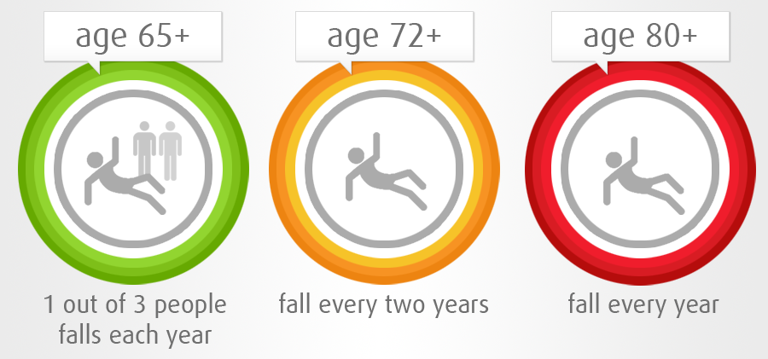

**5.1 Problem Statement**

One sentinel event – an unexpected incident that can result in death or serious harm – often overlooked in older adults is a fall. Various studies has shown that about one in three people older than age 65 will experience a fall in one year.

People in this age range who fall and fracture their hip have a 25 percent to 30 percent chance of dying after one year. In addition, these people often cannot regain their earlier level of independence. Falls are the most common reason for nursing home placement.

Both of these problems typically have several contributing factors. They may include:

* Problems with vision such as cataracts, macular degeneration, diabetic eye changes and glaucoma.
* Uncontrolled pain, which is most often due to arthritis, particularly in the back, hips or knees.
* Muscle weakness, which often related to prolonged periods of inactivity
* Medicine – the risk of falls increases with the number of medications an individual take. Lightheadedness, particularly when getting up from a lying or sitting position, can indicate that blood pressure medications are too strong. Psychotropic medications like antidepressants and antipsychotic medications all increase the danger of falls.

The omnipresent issue of falling fortunately is not inevitable, however, lacklustre measures and insufficient awareness are being practiced by the general public; thus resulting in the exponential increase of elderly people succumbing to this preventable death cause.We strive to curb this ubiquitous and alarming problem with innovative inventions of our making.

**5.2 Term Definition**

1. Smart Walking Stick (Swalk Stick) is the invention

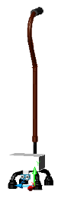

Digram 5.2.1

1. TRIZ - "theory of the resolution of invention-related tasks") is "a problem-solving, analysis and forecasting tool derived from the study of patterns of invention in the global patent literature".
2. Arduino - Arduino is an open source computer hardware and software company, project, and user community that designs and manufactures [single-board microcontrollers](https://en.wikipedia.org/wiki/Single-board_microcontroller) and [microcontroller](https://en.wikipedia.org/wiki/Microcontroller) kits for building digital devices and interactive objects that can sense and control objects in the physical and digital world.
3. IoT - The Internet of Things (IoT) is the network of physical devices, vehicles, home appliances, and other items embedded with [electronics](https://en.wikipedia.org/wiki/Electronics), [software](https://en.wikipedia.org/wiki/Software), [sensors](https://en.wikipedia.org/wiki/Sensor), [actuators](https://en.wikipedia.org/wiki/Actuator), and [connectivity](https://en.wikipedia.org/wiki/Internet_access) which enables these things to connect and exchange [data](https://en.wikipedia.org/wiki/Data), creating opportunities for more direct integration of the physical world into computer-based systems, resulting in efficiency improvements, economic benefits, and reduced human exertions.
4. Smart – Possessing Intelligence
5. Industry 4.0 - Industry 4.0 is a name given to the current trend of [automation](https://en.wikipedia.org/wiki/Automation) and data exchange in [manufacturing](https://en.wikipedia.org/wiki/Manufacturing) [technologies](https://en.wikipedia.org/wiki/Technologie).

**5.3 Scope**

Based on the problem statement stated, we have defined the objectives of our project to solve 3 important issues:

1. Emergency state (Lightning responses)

2. Health monitoring (Data logging and tracking)

3. Prevention (Reducing the risks)

Below are the perceived objectives we are projected to address:

• Aid the elderly and the blind in daily activities

• Enable quickfire responses and notification of individuals in dire need

• Save more lives

• Reduce incidents of senior citizens succumbing to falls

• Monitor health conditions of the elderly

• Alert the elderly when obstacles in the path of his/her movement are detected

• Track location of patients with Alzheimer’s (progressive mental deterioration that can occur in middle or old age, due to generalized degeneration of the brain. It is the most common cause of premature senility)

**5.4 Research Boundary**

The research limits to creating the product of the hardware and software features to provide the following functionality:

* Light up automatically when the user is walking in the dark
* Alert by ringing buzzer’s sound when the user is about to hit an object
* Vibrate the stick when the user is about to hit obstacles
* Send SMS to the user’s family members or closed-friends when the user is in emergency.
* Locate the user’s position accurately when the user needs help
* Send SMS to the user’s family members when the user falls while dropping the walking stick.
* Auto-charge the batteries using solar power

**5.5 Comparative previous research**

We also conducted research in several other systems where providing the similar features and functionality.

* Smart Windows Lighting System
* Smart Automated Home System
* Smart Alarm System
* Smart Door Alarm System
* Smart Phone
* GPS System
* SMS System
* LED System

**6.0 Methodology**

The followings describe the 4 stages, 7 steps of Project Management Methodology:

|  |  |
| --- | --- |
| Steps | Activity |
| 1. Identifying a problem | We conducted the followings:   * Brainstorming and laying out various ideas * Finalising on the most serious issue to tackle * Meticulous research into the problem statement from various sources * Interviews with professionals, doctors, nurses, teachers, mentors, team members and users to further reinforce problem statement * Summarising the problem statement and its research. |
| 1. Proposing a solution | Based on the 3 stated objectives, we have decided to use the hardware components as below:   * Arduino to control the sensors * Gyroscope sensor to detect the fall of the user * Temperature sensor to detect the surrounding temperature and humidity * GPS sensor to locate the exact position the user is. * SMS Module sensor to send messages to the user’s family members in the case of an accident * Vibration sensor to vibrate the walking stick if obstacles in close proximity are detected * Pipe to resemble the walking stick for prototype development |
| 1. Planning the prototype | We divided the project into 3 stages of development:   1. Hardware purchase and construction  * Identify and buy slated materials, checking its functionality and incorporating each of the sensors into the Arduino board  1. Software development  * Identify programming IDE, develop programs, test and refine concurrent programmes as well as combining programs if necessary.  1. Integration of Software and Hardware  * Load programs into the Arduino brain * Conduct live testing to each of the sensors |
| 1. Developing and manufacturing the prototype | 1. Test specific components 2. Load programs into the Arduino 3. Check the functionality of each sensors 4. Connect sensors to the board 5. Assemble sensor to the board 6. Saw the pipe for the body 7. Assemble the components and sensors into a project box 8. Assemble the project box onto the pipe 9. Combine final code to load into the Arduino board 10. Test the code 11. Construct the pipe and attach full wiring 12. Label and decoration 13. Evaluation and modification 14. Screw and fixture 15. Testing all components collectively |
| 1. Testing the prototype | 1. Testing it with team members 2. Testing it with teachers and mentors |
| 1. Live user testing | Undergoing tests with final users in real-life environments |
| 1. Final report / Improvement plan | 1. Final report to summarise the entire procedure and success of the project 2. Improvement plans to make increment changes and enhancement in the near future |

**6.1 Design**

As mentioned briefly in the Problem Statement, the Smart Walking Stick aims to obliterate a broad category of ‘Gordian Knot’ difficulties blighting the lives of the elderly into utter oblivion. In this case, our invention will prioritize the strengthening and reinforcement of the following:

1. Personal emergency assistant - Most of the elderly WSU (denoted as Walking Stick Users) needs a personal assistant at all times. Some unfortune elderly individuals who live alone risk of falling down and being unable to stand up again. If such circumstances occur, rescue and recovering measures are usually lengthy and ineffective which further hampers their already deteriorating condition. The advent of the Smart Walking Stick allows users to contact and alarm emergency personals in such situations. We strongly emphasize on swift responses to address these problems at hand to increase the chances of survival. These situations are such as during a heart attack, stroke, physical assault by perpetrators, kidnapping, fainting, falls and many more.

2. 24 hours monitoring - There are over nearly 44 million people around the world suffering from Alzheimer’s disease. Some of them are in the latter stages of this health complication which points to serious losses in memory such as forgetting even the place of their residence. The Smart Walking Stick assists by monitoring their movements and habits on a daily basis. This includes sensors that detect the location, temperature, humidity of the surrounding environment as well as obstacles in the dark or for the blind.

3. Risk avoidance – Through constant and discrete research, we found out that one third of senior citizens experience a fall annually when they reach 65 and the chances increases drastically as they age. This is because elders have reduced sensitivity to surroundings and muscles are weak to contract and relax. Moreover, most blind people do not have any assisting tools that are able to alert them of obstacles in path of their movement. We need a mechanism to monitor and prevent elders from the perpetual exposure to risk and dangers by notifying with a message in terms of vibration or sound.

**6.2 Details, Material Used**

Below is the Design Specification:

**Body structured by aluminum**

* A very lightweight, but strong and durable material
* Generates a protective oxide coating and is highly corrosion resistant.
* A green material as it is recyclable. The re-melting of aluminum requires little energy: only about 5 percent of the energy required to produce the primary metal initially is needed in the recycling process

**Intrinsic and highly detailed handle design**

* Inspired by the shape of a 'swan neck'
* Designed to allow users to feel the stick as balanced and comfortable
* An ergonomic handle shaped to fit the curvature of the user’s hand

**Rubber-supported base**

* A tip of such nature should grip the floor well as it absorbs the pressure exerted by the weight of the user.
* The elasticity and resilience of rubber maintains its shape well and does not wear off easily.

**‘Pin-to-multiple hole’ concept**

Allows to adjust the length of the Walking Stick manually with ease to suit your personal preferences.

**Large base area**

* Ensure the stability of both the walking stick and the user especially in rough or rocky terrains.
* Its curvature design on all supports enables it to withstand even the strongest of forces.

**Circuit Design:**

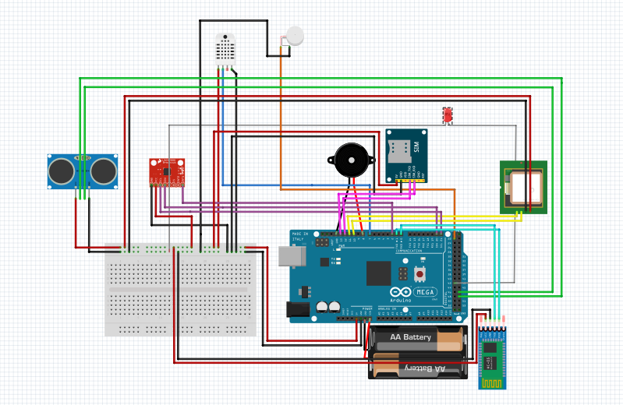

Diagram 5.2.1

**Hardware Specification Requirements:**

**Arduino Mega**

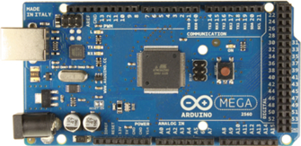The Arduino Mega is the so-called ‘brain’ of the project. The entire project will be created and developed on the basis of this essential component as the Arduino Mega acts as a hub to program various sensors using the Arduino IDE.

Diagram 6.2.2

The Arduino Mega 2560 is a microcontroller board based on the ATmega2560 (datasheet). It has 54 digital input/output pins (of which 14 can be used as PWM outputs), 16 analog inputs, 4 UARTs (hardware serial ports), a 16 MHz crystal oscillator, a USB connection, a power jack, an ICSP header, and a reset button. It contains everything needed to support the microcontroller; simply connect it to a computer with a USB cable or power it with a AC-to-DC adapter or battery to get started.

**MPU6050 3 Axis Gyroscope Module for Arduino**

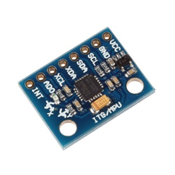**Gyroscope sensor**

Gyro sensors, also known as angular rate sensors or angular velocity sensors are devices that sense angular velocity. In simple terms, angular velocity is the change in rotational angle per unit of time. Angular velocity is generally expressed in deg/s (degrees per second).

Diagram 6.2.3

• Chip: MPU-6050

• Power supply :3-5v

• Gyroscopes range: ± 250 500 1000 2000 ° / s

• Acceleration range: ± 2 ± 4 ± 8 ± 16g

It is calibrated to give a reading of zero when the device is kept on a plane horizontal surface. Any change in orientation of the device is measured by the gyro sensor and will respond to changes in its value.

Thus, we use the gyro sensor as a fall detection component as an exceeded value of angular rate will trigger numerous other sensors to alarm and detect the fall of the user.

**GY-NEO6MV2 GPS module for Arduino**

**GPS Module**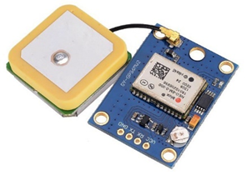

The GPS Module is used to identify and track the users’ location in the form of longitude and latitude.

We used this sensor to keep track of the user’s location

Diagram 6.2.4

and movement at all times. In the light of an accident, the user’s family and friends as well as health personnel can be notified with the pinpoint accuracy of the exact location of the occurrence.

**SIM900A GSM GPRS Wireless Extension Module Board - Free Antenna (SIM Card module)**

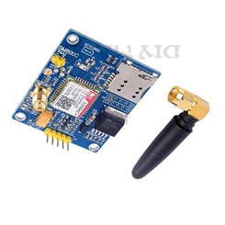• Support 2 mobile phone; 3,4G card

• Low power consumption: 1.0 mA (sleep mode)

• Serial port circuit: support for 3.3V single chip microcomputer

• TTL serial port: support 3.3 and 5V single chip microcomputer.

Diagram 6.2.5

• Antenna interface circuit(SMA bend female port)

• SIM card circuit(flip SIM slot)

We used the SIM Card Module to send notifications to the users’ registered emergency contact about the users’ location in the case of an incident. As a result, friends and families of the victim can act as swiftly as possible to provide the assistance needed.

**Ultrasonic Sensor**

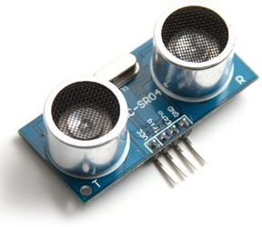The HC-SR04 Ultrasonic Module has 4 pins, Ground, VCC, Trig and Echo. The Ground and the VCC pins of the module needs to be connected to the Ground and the 5 volts pins on the Arduino Board respectively and the trig and echo pins to any Digital I/O pin on the Arduino Board.

Diagram 6.2.6

We used the ultrasonic sensor to:

* Detect obstacles around the users by producing sound waves; receiving the reflected waves to calculate the estimate distance of the obstacles.
* An obstacle in close proximity will vibrate the Smart Walking Stick to alert users.

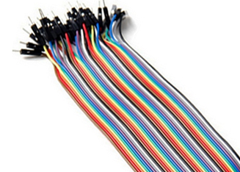**Male-Male Jumper Wire**

• Length: 20cm

• 10 different colours

Easy prototyping connections on most of the boards available in market except for the straight turn pin (round hole). Multiple jumpers can be connected next to one another on a 0.1" header.

Diagram 6.2.7

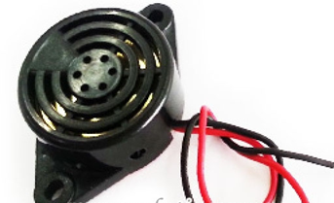**Buzzer**

• Buzzer 3-24V with wire

• Diameter: 3.0cm

The Buzzer acts as an alarm to alert the surrounding environment in the case of an accident taking place. The loud and cacophonous noise of it will catch the attention of passer-byes.

Diagram 6.2.8

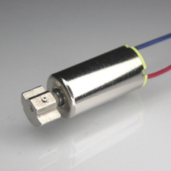**Vibration Motor**

**3.7v 18000rpm High Speed Coreless Small Vibration DC Motor**

•Speed: 18000 rpm

•Rated voltage: 3 V

Diagram 6.2.9

•Rated current: 50mA

The Vibration Motor will start to vibrate and notify the users in specific circumstances such as avoiding an obstacle in the path of the user’s movement.

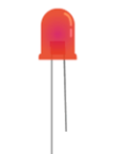**LED**

The LED functions as a light source to enable the user to have a better vision in dark circumstances. The LED works in accordance with the LDR so that it can light up automatically in an environment of low light intensity.

Diagram 6.2.10

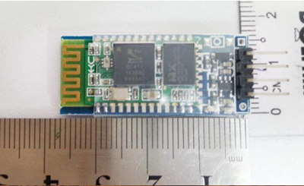**Arduino HC-06 Serial Port Bluetooth Module HC06 Wireless**

Serial port Bluetooth module. Can be used for a serial port replacement to establish connection between MCU, GPS, and PC to your embedded project and etc.

HC-06 can be set to master or slave by user.

Diagram 6.2.11

* Bluetooth protocol: Bluetooth specification v2.0+EDR
* Frequency: 2.4GHz ISM Band
* Speed: Asynchronous: 2.1Mbps(Max)/160kbps, Synchronous: 1Mbps`
* Security: Authentication and encryption
* Power supply: +3.3VDC 50mA
* Working temperature: -20 ~ +75 Centigrade

**DHT11 temperature and humidity sensor module for Arduino**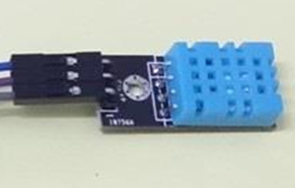

* Operating voltage: 5Vdc.
* Temperature measurement range: 0 to 50 degree with +-2 degree accuracy.
* Humidity measurement range: 20 to 80% with 5% accuracy.

Diagram 6.2.12

* Pinout:
  + + = 5V
  + OUT = Data
    - = Ground

The Temperature and Humidity Sensor is used to detect the temperature and humidity of the surroundings in which the user is situated precisely.

These electronic components and sensors is a fundamental part and parcel of the entire project. Each sensor that we have infused into the project elements of our Smart Walking Stick has its own highly specific function; allowing it to process data and information effectively and efficiently in accordance to various circumstances. Some of the components are also interconnected with one another to form a cohesive unit responding to stimulants of our everyday lives. As a result, Team Voltage vehemently emphasizes our electronic components as the foundations laid for the functionality of the entire project.

**6.4 Tools**

We have used a few primary tools and equipment to complete our projects, notable items are as follows:

|  |  |
| --- | --- |
| Hardware | 1. Soldering Machine 2. Hot Glue Gun 3. 3D Printer 4. Electric Hand drill |
| Software | 1. Programming IDE Environment Arduino 2. SIM Card 3. Prepaid 3G Communication Network |

**6.5 Procedure**

Combining the methodology, we have established a functional Work Breakdown Structure (WBS) to divide the work into activities to execute in a systematic procedure or process.

**Risk Management – Problem Solving Techniques**

We realized that unpredictable and adverse scenarios could happen over the course of the project, thus we created a list of possible risks and comprehensive ways to resolve them with ease. Understanding clearly how we could fix our problems lead to a more relaxed environment where our concentration wasn’t shifted from completing our main tasks. Risk management is yet another amazing technique to ensure our project was completed within the rigorous deadline.

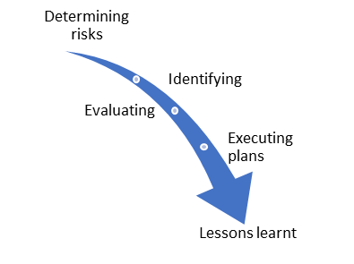The Process

1. Determining the risks.

2. Identify, characterize and assess the scope of errors

3. Evaluating the vulnerability of critical aspects to specific threats

4. Manage ways to dispel those threats.

5. Learn from previous mistakes to prevent such future situations

from occurring.

**Time Management – Defeating Constrains**

Another important factor which has been constantly overlooked by almost everyone. Flawless time management ensures a smooth sailing process in our preparations for the competition and avoids abrupt disruptions and unforeseen circumstances. With our preparation schedules for the SIRIM Invention, Innovation and Technology Expo 2018 seeming as watertight; time management has definitely inserted discipline and a sense of urgency into the team to get the job done

Weekly Agendas

|  |  |  |
| --- | --- | --- |
| Action | Description | Resources |
| Concluding & Finalising Ideas | Opting the most glaring and widespread problem statement to tackle as well as brainstorming solutions to counteract the issue. | Sources of information (Internet, books, etc) |
| Component/ Tools Purchasing | Purchasing the necessary electronic components, apparatus and tools for the manufacturing process. | Cash |
| Manufacturing of Prototype | Combining the body structure with its constituent components such as sensors. | Tools and Apparatus, Sensors, 3D Printer |
| Program Coding | Write programs in coded language to instruct the sensors to perform specific tasks in a given environment. | Arduino IDE |
| Portfolio | Creating the project template to convey our team’s message clearly to the audience in written language. | Photoshop |
| Presentation Slide and Script | Summarising our entire project and listing out the important aspects in the presentation slide as well as preparing the speech during the judging procedures. | Prezi |
| Booth Preparation | Plan and organise the arrangement of the set-up of our booth with all required project elements available. | Banners, Posters and Miscellaneous decorations |
| Outreach Activities | Interacting with the general public and allowing them to provide useful feedback and responses regarding their opinions towards our project. | Camera, Interview Forms |
| Final Rehearsal | Practice and demonstrate each of our roles as if live during the competition day. | All project elements |

|  |  |  |  |  |  |  |  |
| --- | --- | --- | --- | --- | --- | --- | --- |
|  | Monday | Tuesday | Wednesday | Thursday | Friday | Saturday | Sunday |
| Week 1 |  |  |  |  |  | Discussion |  |
| Week 2 |  | Concluding & Finalising Ideas | Planning | Component Purchase | Component Purchase | Tools and Apparatus Purchase |  |
| Week 3 | Testing of Components | Testing of Components | Testing of Components | Manufacture of Prototype | Manufacture of Prototype | Manufacture of Prototype | Manufacture of Prototype |
| Week 4 | Manufacture of Prototype | Manufacture of Prototype | Manufacture of Prototype | Coding | Coding | Compile and Run Program | Final Test |
| Week 5 | Portfolio Preparation | Portfolio Preparation | Portfolio Preparation | Portfolio Preparation | Portfolio Preparation | Portfolio Preparation | Portfolio Preparation |
| Week 6 | Discussion | Presentation Slide and Script Preparation | Presentation Slide and Script Preparation | Presentation Slide and Script Preparation | Presentation Slide and Script Preparation | Outreach | Outreach |
| Week 7 | Outreach | Video Editing | Video Editing | Booth Management and Preparation | Booth Management and Preparation | Booth Management and Preparation | Booth Management and Preparation |
| Week 8 | Competition | Competition | Competition |  |  |  |  |

**Financial Management – Control Expenditure**

Managing wisely is another important factor to guarantee that all required materials are purchased without running out of cash. Thus, we have created a budget list including every aspect from manufacturing materials to flights and accommodation based on rough estimations to be aware of the amount we require and to prevent our expenditures from exceeding our proposed budget.

|  |  |  |
| --- | --- | --- |
| COMPONENTS | QUANTITY | PRICE(RM) |
| HC SR04 Ultrasonic sensor module | 1 | 14.50 |
| Arduino DHT11 Temperature and Humidity sensor | 1 | 4.00 |
| 1.5V vibration motor | 1 | 6.50 |
| 5V LED strip | 1 | 32.00 |
| 5mm RED LED,220Kω resistor, LDR | 1 | 0.30 |
| Arduino MEGA 2560 Rev3 | 1 | 45.00 |
| 4 stand walking stick | 1 | 39.00 |
| Arduino GY-NEO6MV2 GPS Tracking Module with Antenna MWC AMP2.5 | 1 | 49.50 |
| SIM900A GSM GPRS Wireless Extension Module Board | 1 | 58.90 |
| 6DOF MPU 6050 GY-521 3 Axis Gyro Accelerometer Sensor Module | 1 | 13.90 |
| HND-42 90dB 3-24v 12V DC Large Piezo Buzzer | 1 | 4.00 |
| Arduino SPI ICSP interface Micro SD Card Adapter Reader Module | 1 | 5.90 |
| Portfolio | 3 | 150 |
| Poster | 1 | 36.00 |
| Banner | 2 | 320.00 |
| GRAND TOTAL |  | 629.50 |

**Cost/Benefit Table**

|  |  |  |  |  |
| --- | --- | --- | --- | --- |
| Ideas | Cost | Benefit | Action | Reason |
| Importing materials from foreign countries | Extremely costly and bearing high risks | Higher quality materials with global approval | Opted for locally produced materials | Budgets constrains and lengthy shipping time frame |
| Undergoing preparations during school hours | Greatly affects our school grades and academic performance | Accelerate our project preparations and granting time for increment changes and improvements | Seek written permission from the headmaster to proceed with our project during school hours | Restrained amount of time spurred us to engage in such a risky move |

A cost/benefit table was created and adhered by the team leading up to the National Finals. This allowed us to prioritize and monitor major tasks, as well as removing unnecessary time-consuming jobs.

**Effective Team Communication**

WEEKLY MEETINGS

We held group meetings thrice a week to ensure all designated work were completed. Minutes were recorded, actions identified and tasks delegated.

COMMUNICATION TOOLSGMAIL: A Gmail account was created so all members have access to emails sent by sponsors, collaborating businesses and etc.FACEBOOK: Group chat involving all members were created to establish real-time communication. It also allowed us to exchange information and reporting personal progress within split seconds.

**Maintaining Team Productivity**

HIGH TEAM MORALEPlays an indispensable role in maintaining productivity, forming stronger relationships and developing a efficient, high-spirited work environment that motivates everyone to work to their limits. Team Hermes has progressed to an extremely close-knit team. We acknowledged the importance of infusing the ‘fun factor’ as means to create a balance between endeavoring on serious tasks as well as celebrating achieved milestones.

COMPLETION LISTTeam members were required to write down the tasks that they have completed for each week. This process built enthusiasm and reinforced the idea that our ambitious plans were achievable.

**7.0 Experiment**

At the spur of the moment when the Smart Walking Stick’s user falls down,

1. The gyroscope sensor will detect sudden changes in angular value.

2. The buzzer and LED will respond within 10 seconds to catch the attention of other people.

- The buzzer sounding a loud and cacophonous noise

- The LED beaming incessant and blinding rays

3. If the walking stick remains in a slanted/fallen position after 10 seconds, the SIM Card Module will send a message to the emergency contact as stated and embedded in the Arduino IDE.

4. Emergency health assistance will be delivered as rapidly as possible to wind down the severity of an accident with swift medical attention.

On the other hand, as a popular idiom goes by saying, “Prevention is better than cure”.

1. The ultrasonic sensors detect obstacles within a close proximity of the user’s intended path of movement.

2. The vibration motor is activated which causes the walking stick to vibrate vigorously in quick successions.

3. The user is notified of the obstacle and an accident is prevented. (Highly applicable for the blind or visually impaired)

**7.1 Data Collection, Observation, Photos and Records**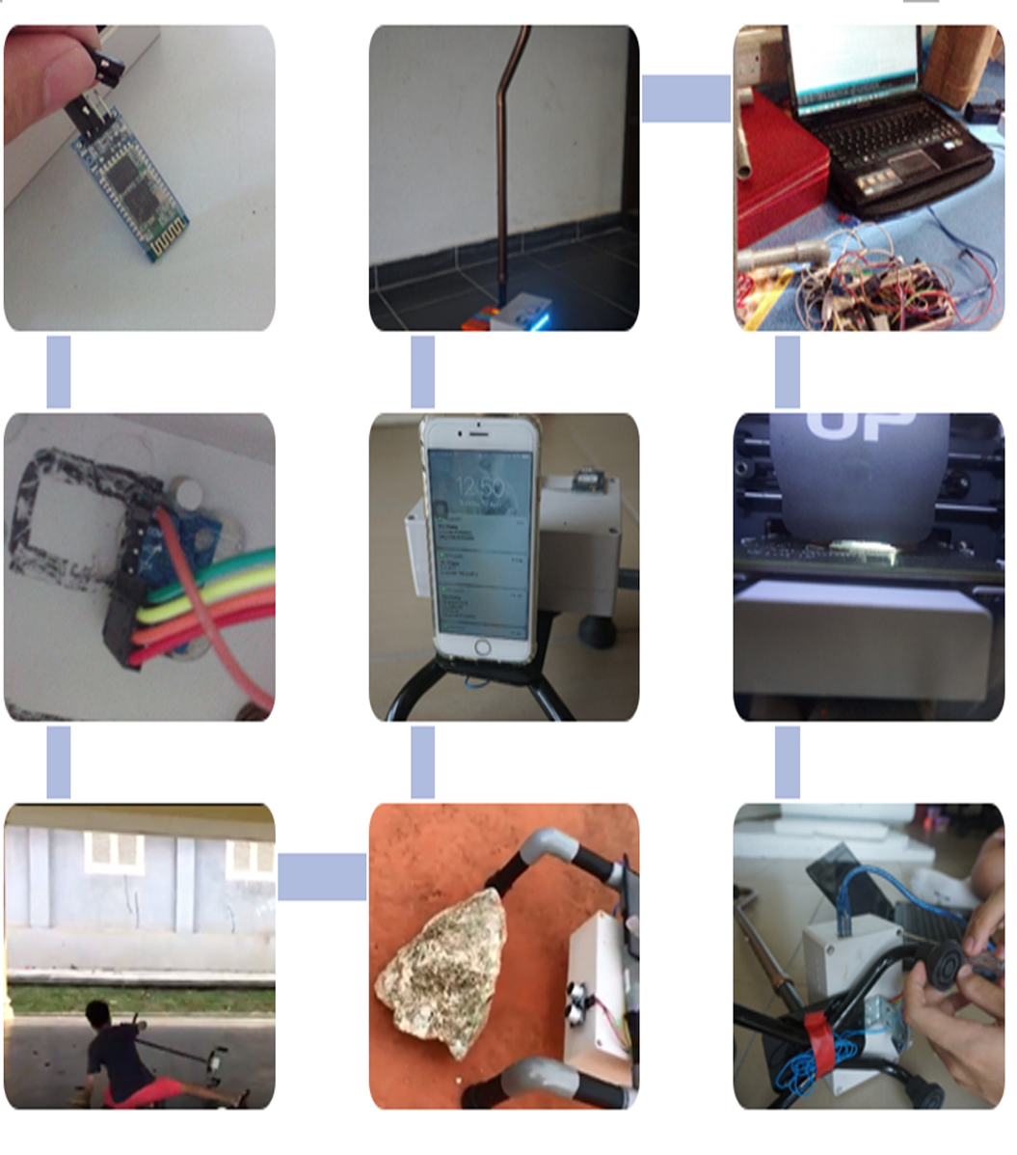

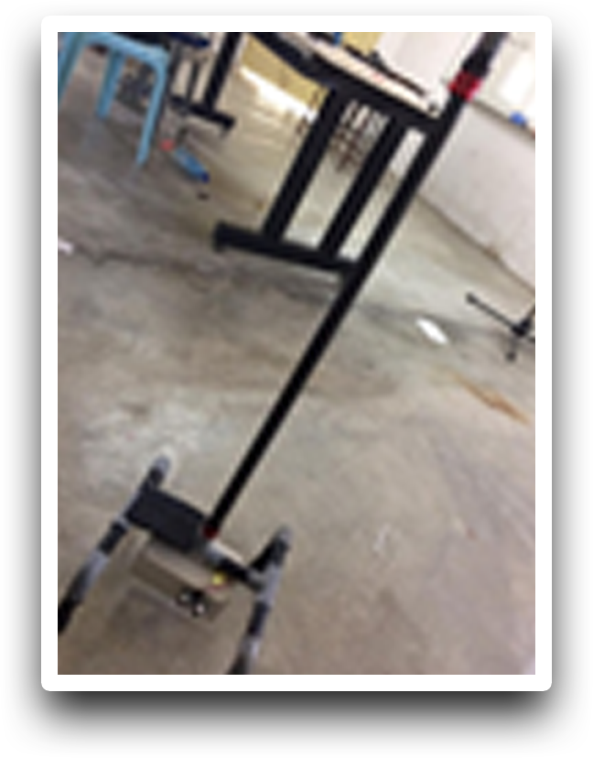

1. Testing of hardware components and sensors
2. Sensor Positioning and Installation
3. User Fall Test
4. Obstacle Proximity Test
5. Monitoring Test – GPS Location
6. LED and Power Up Test
7. Integration procedures using hardware and software components
8. 3D Printing Prototype
9. Fastening Screws and Components
10. Final Prototype

**Hardware And Software Programs Specification and Records**

|  |  |
| --- | --- |
| Arduino Mega | All pins stated below connected with the sensors |
| MPU6050 3 Axis Gyroscope Module for Arduino Gyroscope sensor | Pin 16 |
| GY-NEO6MV2 GPS module for Arduino | RX---pin 10  TX---pin 11 |
| SIM900A GSM GPRS Wireless Extension Module Board - Free Antenna (SIM Card module) | TX---pin 18  RX---pin 19 |
| Ultrasonic Sensor | Trigger pin---pin 52  Echo pin---pin 53 |
| LDR |  |
| Male-Male Jumper Wire |  |
| Buzzer | pin 8 |
| 2 Way Dual 18650/18500/14500/17500 3.7V Li-ion Lithium Battery Charger | 5 V connector |
| Vibration Motor | pin 22 |
| LED |  |
| 112X84-6 6V 200mA 1.1W High Efficiency Solar Panel | VIN , GND pin |
| LC 18650 3.7V 3800MAH Blue Li-ion Rechargeable Lithium Battery | VIN, GND pin |
| Arduino HC-06 Serial Port Bluetooth Module HC06 Wireless | TX---pin 0  RX---pin1 |
| DHT11 temperature and humidity sensor module for Arduino | pin 7 |

1. 12.2 Software

|  |  |
| --- | --- |
| Define main program - Arduino | //ERFINDER CODE  #include "TinyGPS++.h"  #include "SoftwareSerial.h"  #include <SoftwareSerial.h>  #include <dht11.h>  #include<Wire.h>  const int MPU_addr=0x68; // I2C address of the MPU-6050  int16_t AcX,AcY,AcZ,Tmp,GyX,GyY,GyZ;  dht11 DHT;  #define DHT11_PIN 7  SoftwareSerial serial_connection(10,11); //RX=pin 10, TX=pin 11  TinyGPSPlus gps;  int PulseSensorPurplePin = 0;  int Signal;  const int pinSpeaker = 8;  const int trigPin = 52;  const int echoPin = 53;  SoftwareSerial mySerial(18, 19); |
| Gyro sensor | Wire.beginTransmission(MPU_addr);  Wire.write(0x3B); // starting with register 0x3B (ACCEL_XOUT_H)  Wire.endTransmission(false);  Wire.requestFrom(MPU_addr,14,true); // request a total of 14 registers  AcX=Wire.read()<<8|Wire.read(); // 0x3B (ACCEL_XOUT_H) & 0x3C (ACCEL_XOUT_L)  AcY=Wire.read()<<8|Wire.read(); // 0x3D (ACCEL_YOUT_H) & 0x3E (ACCEL_YOUT_L)  AcZ=Wire.read()<<8|Wire.read(); // 0x3F (ACCEL_ZOUT_H) & 0x40 (ACCEL_ZOUT_L)  Tmp=Wire.read()<<8|Wire.read(); // 0x41 (TEMP_OUT_H) & 0x42 (TEMP_OUT_L)  GyX=Wire.read()<<8|Wire.read(); // 0x43 (GYRO_XOUT_H) & 0x44 (GYRO_XOUT_L)  GyY=Wire.read()<<8|Wire.read(); // 0x45 (GYRO_YOUT_H) & 0x46 (GYRO_YOUT_L)  GyZ=Wire.read()<<8|Wire.read();  if(AcZ<10000)  {  tone(pinSpeaker,262,250);  delay(1000);  AcZ=Wire.read()<<8|Wire.read(); // 0x3F (ACCEL_ZOUT_H) & 0x40 (ACCEL_ZOUT_L)  if (AcZ<10000)  {  tone(pinSpeaker,262,250);  delay(1000);  AcZ=Wire.read()<<8|Wire.read(); // 0x3F (ACCEL_ZOUT_H) & 0x40 (ACCEL_ZOUT_L)  if (AcZ<10000)  {  tone(pinSpeaker,262,250);  delay(1000);  AcZ=Wire.read()<<8|Wire.read(); // 0x3F (ACCEL_ZOUT_H) & 0x40 (ACCEL_ZOUT_L)  if (AcZ<10000)  {  tone(pinSpeaker,262,250);  delay(1000);  AcZ=Wire.read()<<8|Wire.read(); // 0x3F (ACCEL_ZOUT_H) & 0x40 (ACCEL_ZOUT_L)  if (AcZ<10000)  {  tone(pinSpeaker,262,250);  delay(1000);  AcZ=Wire.read()<<8|Wire.read(); // 0x3F (ACCEL_ZOUT_H) & 0x40 (ACCEL_ZOUT_L)  if (AcZ<10000)  {  tone(pinSpeaker,262,250);  delay(1000);  AcZ=Wire.read()<<8|Wire.read(); // 0x3F (ACCEL_ZOUT_H) & 0x40 (ACCEL_ZOUT_L)  if (AcZ<10000)  {  tone(pinSpeaker,262,250);  delay(1000);  AcZ=Wire.read()<<8|Wire.read(); // 0x3F (ACCEL_ZOUT_H) & 0x40 (ACCEL_ZOUT_L)  if (AcZ<10000)  {  tone(pinSpeaker,262,250);  delay(1000);  AcZ=Wire.read()<<8|Wire.read(); // 0x3F (ACCEL_ZOUT_H) & 0x40 (ACCEL_ZOUT_L)  if (AcZ<10000)  {  tone(pinSpeaker,262,250);  delay(1000);  AcZ=Wire.read()<<8|Wire.read(); // 0x3F (ACCEL_ZOUT_H) & 0x40 (ACCEL_ZOUT_L)  if (AcZ<10000)  {  tone(pinSpeaker,262,250);  delay(1000);  AcZ=Wire.read()<<8|Wire.read(); // 0x3F (ACCEL_ZOUT_H) & 0x40 (ACCEL_ZOUT_L)  if (AcZ<10000)  {  tone(pinSpeaker,262,250);  AcZ=Wire.read()<<8|Wire.read(); // 0x3F (ACCEL_ZOUT_H) & 0x40 (ACCEL_ZOUT_L)  Serial.println("message sent");  SendMessage1();  }  }  }  }  }  }  }  }  }  }  } |
| Buzzer | if(AcZ<10000)  {  tone(pinSpeaker,262,250);  delay(1000);  AcZ=Wire.read()<<8|Wire.read(); // 0x3F (ACCEL_ZOUT_H) & 0x40 (ACCEL_ZOUT_L)  if (AcZ<10000)  {  tone(pinSpeaker,262,250);  delay(1000);  AcZ=Wire.read()<<8|Wire.read(); // 0x3F (ACCEL_ZOUT_H) & 0x40 (ACCEL_ZOUT_L)  if (AcZ<10000)  {  tone(pinSpeaker,262,250);  delay(1000);  AcZ=Wire.read()<<8|Wire.read(); // 0x3F (ACCEL_ZOUT_H) & 0x40 (ACCEL_ZOUT_L)  if (AcZ<10000)  {  tone(pinSpeaker,262,250);  delay(1000);  AcZ=Wire.read()<<8|Wire.read(); // 0x3F (ACCEL_ZOUT_H) & 0x40 (ACCEL_ZOUT_L)  if (AcZ<10000)  {  tone(pinSpeaker,262,250);  delay(1000);  AcZ=Wire.read()<<8|Wire.read(); // 0x3F (ACCEL_ZOUT_H) & 0x40 (ACCEL_ZOUT_L)  if (AcZ<10000)  {  tone(pinSpeaker,262,250);  delay(1000);  AcZ=Wire.read()<<8|Wire.read(); // 0x3F (ACCEL_ZOUT_H) & 0x40 (ACCEL_ZOUT_L)  if (AcZ<10000)  {  tone(pinSpeaker,262,250);  delay(1000);  AcZ=Wire.read()<<8|Wire.read(); // 0x3F (ACCEL_ZOUT_H) & 0x40 (ACCEL_ZOUT_L)  if (AcZ<10000)  {  tone(pinSpeaker,262,250);  delay(1000);  AcZ=Wire.read()<<8|Wire.read(); // 0x3F (ACCEL_ZOUT_H) & 0x40 (ACCEL_ZOUT_L)  if (AcZ<10000)  {  tone(pinSpeaker,262,250);  delay(1000);  AcZ=Wire.read()<<8|Wire.read(); // 0x3F (ACCEL_ZOUT_H) & 0x40 (ACCEL_ZOUT_L)  if (AcZ<10000)  {  tone(pinSpeaker,262,250);  delay(1000);  AcZ=Wire.read()<<8|Wire.read(); // 0x3F (ACCEL_ZOUT_H) & 0x40 (ACCEL_ZOUT_L)  if (AcZ<10000)  {  tone(pinSpeaker,262,250);  AcZ=Wire.read()<<8|Wire.read(); // 0x3F (ACCEL_ZOUT_H) & 0x40 (ACCEL_ZOUT_L)  Serial.println("message sent");  SendMessage1();  }  }  }  }  }  }  }  }  }  }  } |
| Vibration motor | if(cm < 30){  digitalWrite(22,HIGH);  }  else {  digitalWrite(22,LOW);  } |
| LED |  |
| Solar panel |  |
| Bluetooht |  |
| Temp humidity sensor | int chk;  chk = DHT.read(DHT11_PIN);  Serial.print(DHT.humidity,1);  Serial.print(",\t");  Serial.println(DHT.temperature,1); |
| LDR |  |
| SIM module | void SendMessage1()  {  mySerial.println("AT+CMGF=1"); //Sets the GSM Module in Text Mode  delay(1000); // Delay of 1000 milli seconds or 1 second  mySerial.println("AT+CMGS=\"+60164323431\"\r"); // Replace x with mobile number  delay(1000);  mySerial.print(DHT.humidity,1);// The SMS text you want to send  delay(100);  mySerial.println("%");// The SMS text you want to send  delay(100);  mySerial.print(DHT.temperature,1);// The SMS text you want to send  delay(100);  mySerial.println("C");// The SMS text you want to send  delay(100);  mySerial.print(gps.location.lat(), 6);// The SMS text you want to send  delay(100);  mySerial.println("(Latitude)");// The SMS text you want to send  delay(100);  mySerial.print(gps.location.lng(), 6);// The SMS text you want to send  delay(100);  mySerial.println("(Longitude)");// The SMS text you want to send  delay(100);  mySerial.println((char)26);// ASCII code of CTRL+Z  delay(1000);    } |
| Ultrasonic sensor | long duration, inches, cm;      pinMode(trigPin, OUTPUT);  digitalWrite(trigPin, LOW);  delayMicroseconds(2);  digitalWrite(trigPin, HIGH);  delayMicroseconds(10);  digitalWrite(trigPin, LOW);    pinMode(echoPin, INPUT);  duration = pulseIn(echoPin, HIGH);      inches = microsecondsToInches(duration);  cm = microsecondsToCentimeters(duration);  }  long microsecondsToInches(long microseconds)  {    return microseconds / 74 / 2;  }    long microsecondsToCentimeters(long microseconds)  {    return microseconds / 29 / 2;  } |
| GPS module | while(serial_connection.available())//While there are characters to come from the GPS  {  gps.encode(serial_connection.read());//This feeds the serial NMEA data into the library one char at a time  }  if(gps.location.isUpdated())//This will pretty much be fired all the time anyway but will at least reduce it to only after a package of NMEA data comes in  {  //Get the latest info from the gps object which it derived from the data sent by the GPS unit  Serial.println("Satellite Count:");  Serial.println(gps.satellites.value());  Serial.println("Latitude:");  Serial.println(gps.location.lat(), 6);  Serial.println("Longitude:");  Serial.println(gps.location.lng(), 6);  Serial.println("Speed MPH:");  Serial.println(gps.speed.mph());  Serial.println("Altitude Feet:");  Serial.println(gps.altitude.feet());  Serial.println("");  } |

**8.0 Research Findings**

**INTERVIEWS**

Throughout the preparation procedures, we conducted various interview sessions within the school community (teachers and friends) as well as with members of the public. This was aimed to obtain both professional advice and concrete suggestions to improve our project. It was extremely helpful in refining the Smart Walking Stick as different perspectives have a wide range of opinions. 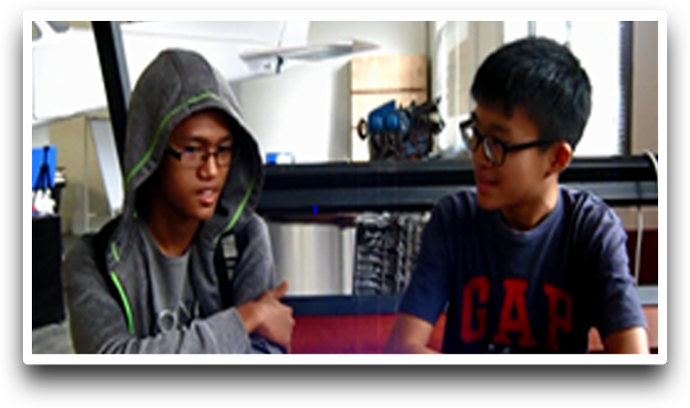

**SCHOOL AND PUBLIC PRESENTATIONS/SHARING** During the course of our preparations, the five of us went from class to class in our school to promote and share our ideas to fellow peers. The aim was to expand and reinforce the strength of our supporting base as well as to intrigue other talented individuals in our school to participate in such scientific challenges like the SIRIM Innovation, Invention and Technology Expo. The measure was a relative success. We also plan to transmit our innovation and ideas to globally acclaimed companies or in public spaces such as Penang Science Fair or Penang Science Cluster in the near future. Such lengths would herald us immense experience in communicating with the public as well as to receive valuable advice from professionals to enhance our project.

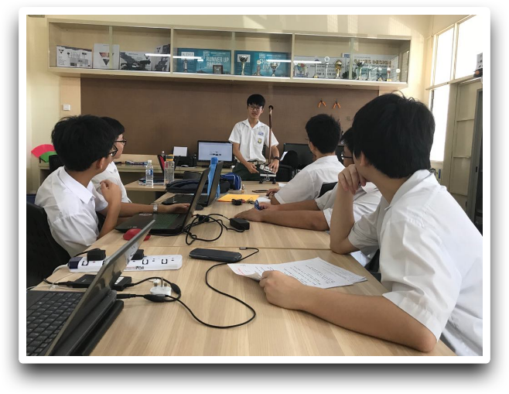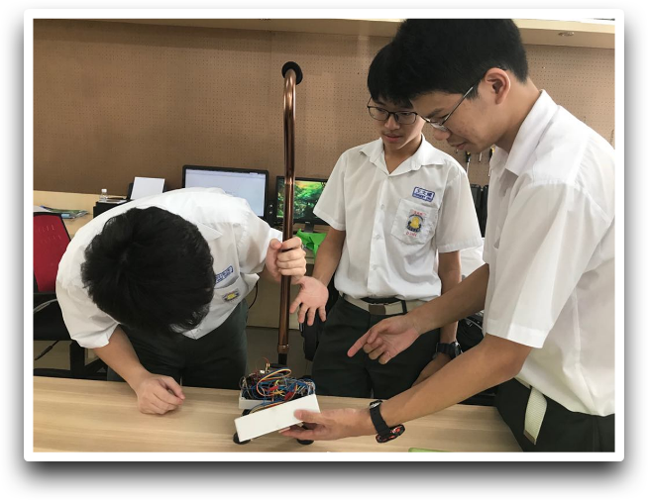

**8.1 Data Analysis and Data interpretation**

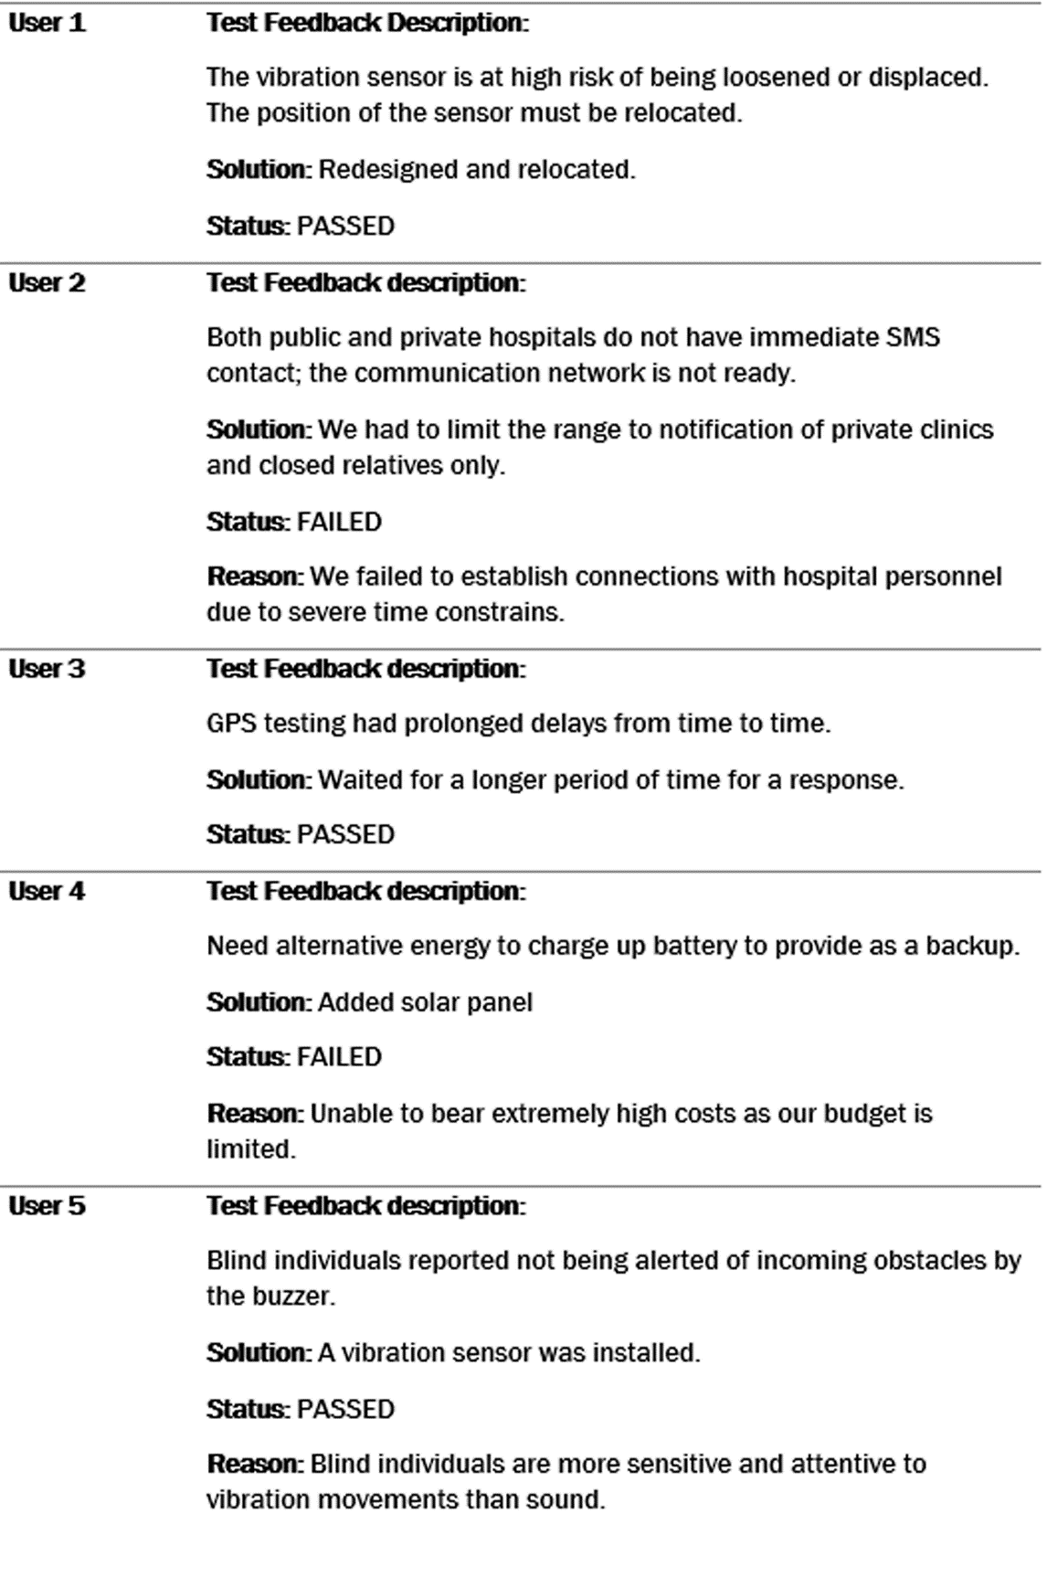

**9.0 Discussion and Summary**

The prototype development of the smart walking stick will build a better world for mankind. The multiple sensors of enabling technology, communication technology, medical emergency and life will assist us for better living in future.

We hope that the prototype can be commercialized where the cost of development will substantially reduce to able to able to help millions of people that facing risks and challenges of disabilities and weak sensory organs.

**9.1 Theory and Practice**

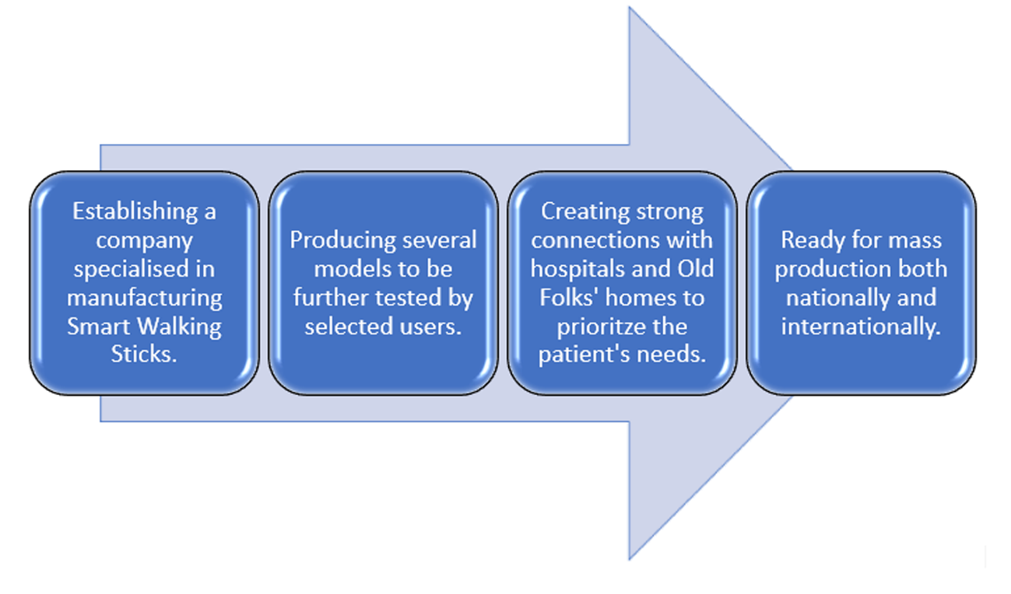Package 1Context: Equipped with Gyro sensor and the GPS System for fall detection purposes, however with the omission of Ultrasonic Sensor and Vibration MotorSelling Price: RM350.00 Bonus: 1-year Full Warranty and 2 years of Free Maintenance FeeUsers: For the Handicap or Physically-Challenged IndividualsPackage 2Context: Equipped with all purposed sensors for both fall detection purposes and warning of impending obstacles ahead. Selling Price: RM450.00 Bonus:1-year Full Warranty and 2 years of Free Maintenance FeeUsers: For the Elderly and the Blind

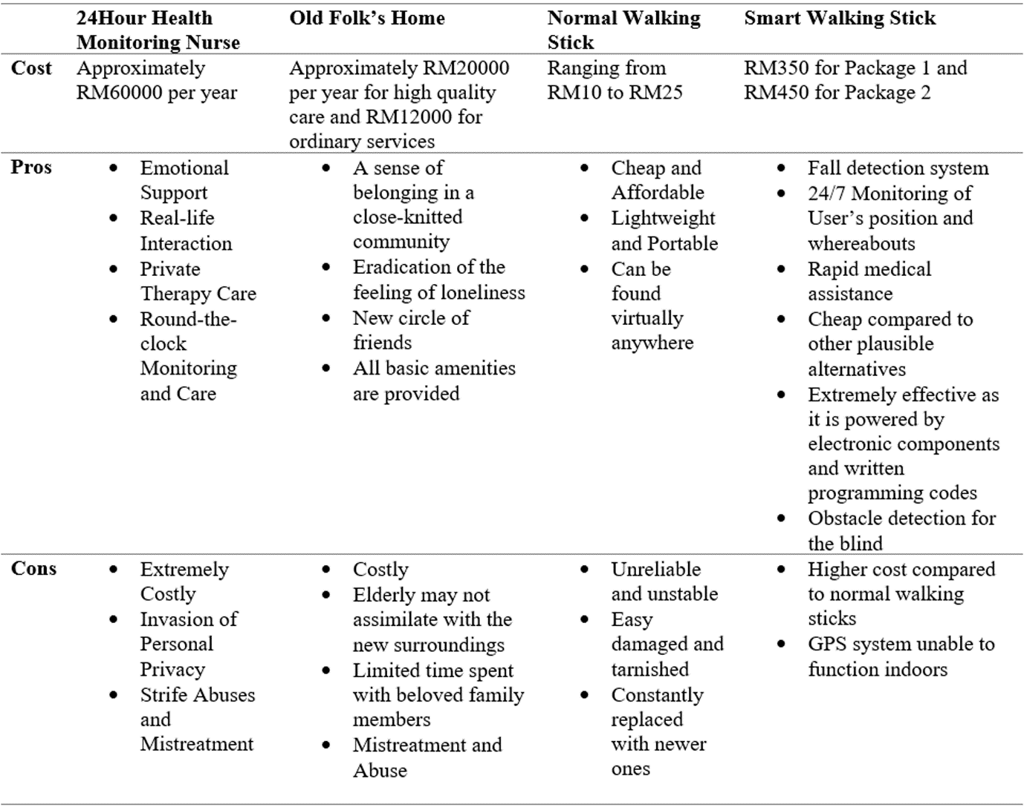

**9.2 Innovation**

Creative ideas that sparked from the intrinsic minds of ours. Our creative approaches play a pivotal role in ensuring the efficient functionality of the Smart Walking Stick.

|  |  |
| --- | --- |
| Taking advantage of current technology | Usage of the SMS Module to convey notifications to emergency contacts in the case of an accident which is the hallmark of our project. This replaces the necessity to hire a round-the-clock personal assistant (maids or helpers) which is extremely costly. |
| Low cost of manufacturing | Usage of low cost and recycling materials for the manufacture of our prototype |
| Open sourcing of IDE Arduino | Use free IDE programming which is a reliable open source. This eases the prospects of future development and addition of new features. |
| Embedded GPS System with pinpoint accuracy | Allows the emergency contact of the user to locate the position of the accident precisely within seconds to hasten the providence of medical assistance. |
| Unprecedented use of Ultrasonic Sensor | Its function to detect obstacles in the user’s pathway reduces the chances of accidents from occurring. |
| Source of light in the dark | The LED strip will automatically light up when light intensity pummels to a certain value. This aids the user in wavering through the dark with a clear vision ahead. |

Innovations that are considered as revolutionary that lends a helping hand to solve problems blighting our everyday lives and to provide utter convenience.

|  |  |
| --- | --- |
| Drawing inspiration and imitation from other forms | Making the Walking Stick ‘smart’ by allowing it to function as efficiently as human sensory organs do by inculcating various electronic sensors. |
| An interconnected network of communication | Combining the cellular network of the stick with the world of limitless internet to ensure unrestricted communication especially during times of emergencies. |
| Medical assistance | Instigating paramount monitoring of individuals in need as well as rapid detection and deliverance of medical assistances to the needy by combining both the electronic and medical world. |

**9.3 Journal reference**

* <https://patents.google.com/patent/US5973618A/en>
* <http://jardcs.org/papers/v10/sp/20181204.pdf>
* <https://patents.google.com/patent/US5755245A/en>

**10.0 Reference**

* <https://health.clevelandclinic.org/older-adults-and-falls-deadly-but-preventable/>
* <https://www.azom.com/article.aspx?ArticleID=14>
* <https://www.thegoldenconcepts.com/blogs/news/15708380-choosing-the-right-walking-stick>
* <http://www.comfortkeepers.com/home/info-center/senior-independent-living/seniors-and-falls-statistics-and-prevention>
* <https://www.cdc.gov/homeandrecreationalsafety/falls/adultfalls.html>
* <https://www.ncoa.org/news/resources-for-reporters/get-the-facts/falls-prevention-facts/>
* <http://news.bbc.co.uk/2/hi/health/790609.stm>
* <https://www.myagedcare.gov.au/getting-started/healthy-and-active-ageing/preventing-falls-in-elderly>
* <https://www.mayoclinic.org/healthy-lifestyle/healthy-aging/in-depth/fall-prevention/art-20047358>
* <https://www.healthcentral.com/article/solution-for-the-pain-pinch-a-walking-stick>
* <http://www.healthpromotion.com.au/Documents/Falls_Seminars/MentalHealth_Falls.pdf>
* [https://nursing.uc.edu/advantage/aging_with_dignity/exploring_aging/gero_ gems/falls_and_mentalhealth.html](https://nursing.uc.edu/advantage/aging_with_dignity/exploring_aging/gero_%20gems/falls_and_mentalhealth.html)
* <http://eatwellnutrition.com.au/2014/03/19/falls-prevention-nutrition/>
* <https://www.sciencedirect.com/science/article/pii/S016749431200176>
* <https://www.ncbi.nlm.nih.gov/pmc/articles/PMC3948728/>
* <https://www.thegoldenconcepts.com/blogs/news/15708380-choosing-the-right-walking-stick>
* <https://www.azom.com/article.aspx?ArticleID=1446>
* <https://www.google.com/url?sa=t&rct=j&q=&esrc=s&source=web&cd=2&cad=rja&uact=8&ved=0ahUKEwjQk7_ch7bUAhXBK48KHaAuDJYQFgikATAB&url=https%3A%2F%2Fen.wikipedia.org%2Fwiki%2FList_of_battery_sizes&usg=AFQjCNH8_8ntYU8DJlKMXNxYqWDfa7ihtA&sig2=m5TXpm80y2DHp0FiaBfDnw>
* <https://www.google.com/url?sa=t&rct=j&q=&esrc=s&source=web&cd=1&cad=rja&uact=8&sqi=2&ved=0ahUKEwix-633h7bUAhWBWrwKHSOpBCgQFghBMAA&url=http%3A%2F%2Fwww.alz.org%2Falzheimers_disease_what_is_alzheimers.asp&usg=AFQjCNGHexpGlow_vS3OIcyT2WY9h50TWQ&sig2=Iwu0fqOt-NpAaUSYgF65Uw>
* <https://www.google.com/url?sa=t&rct=j&q=&esrc=s&source=web&cd=3&cad=rja&uact=8&sqi=2&ved=0ahUKEwix-633h7bUAhWBWrwKHSOpBCgQFghTMAI&url=https%3A%2F%2Fen.wikipedia.org%2Fwiki%2FAlzheimer%2527s_disease&usg=AFQjCNEapF5F928GjV5aA_RY0NuejNzqqA&sig2=5508s1eQGzrWuMRjZ2_VZw>
* <https://www.google.com/url?sa=t&rct=j&q=&esrc=s&source=web&cd=3&cad=rja&uact=8&ved=0ahUKEwjb3ovAibbUAhXFQo8KHXeYCOsQFghDMAI&url=https%3A%2F%2Fen.wikipedia.org%2Fwiki%2FInternet_of_things&usg=AFQjCNEMvTgP-ZbvKr0m77-S13fFQl7jlA&sig2=JgW0NKF_VURbOBrPpqyBWw>
* <https://www.google.com/url?sa=t&rct=j&q=&esrc=s&source=web&cd=2&cad=rja&uact=8&ved=0ahUKEwix2IT6ibbUAhXFp48KHTL_AjsQFgguMAE&url=https%3A%2F%2Fforum.arduino.cc%2Findex.php%3Ftopic%3D332624.0&usg=AFQjCNG8jn6LxqkDwYAYfmOhZ3S0qgIsZw&sig2=uHbbesPL2BsaL7YLj6uBKw>
* <https://www.google.com/url?sa=t&rct=j&q=&esrc=s&source=web&cd=2&cad=rja&uact=8&ved=0ahUKEwi2_cuGirbUAhWHr48KHQ62ACgQFggpMAE&url=http%3A%2F%2Fforum.arduino.cc%2Findex.php%3Ftopic%3D308644.0&usg=AFQjCNEeoIKALRUChLIWi7J63KNcSPuRmA&sig2=wL4_uTzo-XGyC0p3R-jfnA>
* <https://www.google.com/url?sa=t&rct=j&q=&esrc=s&source=web&cd=3&cad=rja&uact=8&ved=0ahUKEwjQ_IyRirbUAhWDv48KHahVBEsQFggwMAI&url=https%3A%2F%2Fforum.arduino.cc%2Findex.php%3Ftopic%3D469789.0&usg=AFQjCNGixR5TveI4wAY0n5YA609hWOH3vg&sig2=mpnBBM7Y-CrpVwEyrcXePg>
* <http://forum.arduino.cc/index.php?topic=321420.0>
* <https://www.google.com/url?sa=t&rct=j&q=&esrc=s&source=web&cd=2&cad=rja&uact=8&ved=0ahUKEwi1tdeZirbUAhUMQo8KHVViCVoQFggpMAE&url=https%3A%2F%2Fforum.arduino.cc%2Findex.php%3Ftopic%3D181917.0&usg=AFQjCNFRiPGk5t12nSqLBpM1kEgNfX3FiA&sig2=8qQ7kYfGWGGkWG9Tf-_r7A>
* <https://en.wikipedia.org/wiki/TRIZ>

**11.0 Appendix I**

Operation and Maintenance Guide

|  |  |
| --- | --- |
| On battery replacement | Open the electrical box and replace the worn-out batteries with brand-new ones. |
| On SIM Card replacement | Open the electrical box and replace the SIM card by inserting it into the slot provided. |
| On phone number / contact addition or alteration | The code is hard written to the program. Please contact the developer to reload the code/recode if you are adding or changing additional cell phone/emergency contact numbers |
| On sensor replacement | A majority of sensors can be easily found on the market and can be replaced by user themselves. However, returning the Smart Walking Stick back to the developer for service is highly recommended as reinstalling sensors require highly professional and meticulous skills |

|  |  |
| --- | --- |
| Power on | The Walking Stick switches on automatically when charged for the very first time. It is ready and available 24/7 to ensure the user’s need. |
| Sensor Calibration | All sensors should be functioning well. This can be checked on the electronic display available on the user’s smartphone. |
| LED light Inspection | The LED light should be switched on. |
| Walk with Ease | Use the Smart Walking Stick as usual. |

**11.1 Appendix II**

**Final Programming Code:**

//ERFINDER CODE

#include "TinyGPS++.h"

#include <SoftwareSerial.h>

#include <dht11.h>

#include<Wire.h>

const int MPU_addr=0x68; // I2C address of the MPU-6050

int16_t AcX,AcY,AcZ,Tmp,GyX,GyY,GyZ;

dht11 DHT;

#define DHT11_PIN 7

SoftwareSerial serial_connection(10,11); //RX=pin 10, TX=pin 11

TinyGPSPlus gps;

int PulseSensorPurplePin = 0;

int Signal;

const int pinSpeaker = 8;

const int trigPin = 49;

const int echoPin = 47;

int analogVal;

const int ldrPin=A0;

const int ledPin=45;

//float latitude=5.405503, longitude=100.295416;

SoftwareSerial mySerial(12, 13);

void setup()

{

pinMode(ledPin, OUTPUT);

pinMode(8,OUTPUT);

pinMode(42,OUTPUT);

pinMode(22,OUTPUT);

Wire.begin();

Wire.beginTransmission(MPU_addr);

Wire.write(0x6B); // PWR_MGMT_1 register

Wire.write(0); // set to zero (wakes up the MPU-6050)

Wire.endTransmission(true);

mySerial.begin(9600); // Setting the baud rate of GSM Module

serial_connection.begin(9600);//This opens up communications to the GPS

Serial.println("GPS Start");//Just show to the monitor that the sketch has started

Serial.begin(9600); // Setting the baud rate of Serial Monitor (Arduino)

delay(100);

Serial.println("DHT TEST PROGRAM ");

Serial.print("LIBRARY VERSION: ");

Serial.println(DHT11LIB_VERSION);

Serial.println();

Serial.println("Type,\tstatus,\tHumidity (%),\tTemperature (C)");

}

void loop()

{

/**while(serial_connection.available())//While there are characters to come from the GPS

{

gps.encode(serial_connection.read());//This feeds the serial NMEA data into the library one char at a time

}

if(gps.location.isUpdated())//This will pretty much be fired all the time anyway but will at least reduce it to only after a package of NMEA data comes in

{

//Get the latest info from the gps object which it derived from the data sent by the GPS unit

Serial.println("Satellite Count:");

Serial.println(gps.satellites.value());

Serial.println("Latitude:");

Serial.println(gps.location.lat(), 6);

Serial.println("Longitude:");

Serial.println(gps.location.lng(), 6);

Serial.println("Speed MPH:");

Serial.println(gps.speed.mph());

Serial.println("Altitude Feet:");

Serial.println(gps.altitude.feet());

Serial.println("");

}**/

long duration, inches, cm;

analogVal = analogRead(ldrPin);

pinMode(trigPin, OUTPUT);

digitalWrite(trigPin, LOW);

delayMicroseconds(2);

digitalWrite(trigPin, HIGH);

delayMicroseconds(10);

digitalWrite(trigPin, LOW);

pinMode(echoPin, INPUT);

duration = pulseIn(echoPin, HIGH);

inches = microsecondsToInches(duration);

cm = microsecondsToCentimeters(duration);

if(cm < 30){

digitalWrite(22,HIGH);

}

else {

digitalWrite(22,LOW);

}

delay(100);

Wire.beginTransmission(MPU_addr);

Wire.write(0x3B); // starting with register 0x3B (ACCEL_XOUT_H)

Wire.endTransmission(false);

Wire.requestFrom(MPU_addr,14,true); // request a total of 14 registers

AcX=Wire.read()<<8|Wire.read(); // 0x3B (ACCEL_XOUT_H) & 0x3C (ACCEL_XOUT_L)

AcY=Wire.read()<<8|Wire.read(); // 0x3D (ACCEL_YOUT_H) & 0x3E (ACCEL_YOUT_L)

AcZ=Wire.read()<<8|Wire.read(); // 0x3F (ACCEL_ZOUT_H) & 0x40 (ACCEL_ZOUT_L)

Tmp=Wire.read()<<8|Wire.read(); // 0x41 (TEMP_OUT_H) & 0x42 (TEMP_OUT_L)

GyX=Wire.read()<<8|Wire.read(); // 0x43 (GYRO_XOUT_H) & 0x44 (GYRO_XOUT_L)

GyY=Wire.read()<<8|Wire.read(); // 0x45 (GYRO_YOUT_H) & 0x46 (GYRO_YOUT_L)

GyZ=Wire.read()<<8|Wire.read();

if(AcZ<10000)

{

tone(pinSpeaker,262,250);

delay(1000);

Wire.beginTransmission(MPU_addr);

Wire.write(0x3B); // starting with register 0x3B (ACCEL_XOUT_H)

Wire.endTransmission(false);

Wire.requestFrom(MPU_addr,14,true); // request a total of 14 registers

AcX=Wire.read()<<8|Wire.read(); // 0x3B (ACCEL_XOUT_H) & 0x3C (ACCEL_XOUT_L)

AcY=Wire.read()<<8|Wire.read(); // 0x3D (ACCEL_YOUT_H) & 0x3E (ACCEL_YOUT_L)

AcZ=Wire.read()<<8|Wire.read(); // 0x3F (ACCEL_ZOUT_H) & 0x40 (ACCEL_ZOUT_L)

Tmp=Wire.read()<<8|Wire.read(); // 0x41 (TEMP_OUT_H) & 0x42 (TEMP_OUT_L)

GyX=Wire.read()<<8|Wire.read(); // 0x43 (GYRO_XOUT_H) & 0x44 (GYRO_XOUT_L)

GyY=Wire.read()<<8|Wire.read(); // 0x45 (GYRO_YOUT_H) & 0x46 (GYRO_YOUT_L)

GyZ=Wire.read()<<8|Wire.read();

if (AcZ<10000)

{

tone(pinSpeaker,262,250);

delay(1000);

Wire.beginTransmission(MPU_addr);

Wire.write(0x3B); // starting with register 0x3B (ACCEL_XOUT_H)

Wire.endTransmission(false);

Wire.requestFrom(MPU_addr,14,true); // request a total of 14 registers

AcX=Wire.read()<<8|Wire.read(); // 0x3B (ACCEL_XOUT_H) & 0x3C (ACCEL_XOUT_L)

AcY=Wire.read()<<8|Wire.read(); // 0x3D (ACCEL_YOUT_H) & 0x3E (ACCEL_YOUT_L)

AcZ=Wire.read()<<8|Wire.read(); // 0x3F (ACCEL_ZOUT_H) & 0x40 (ACCEL_ZOUT_L)

Tmp=Wire.read()<<8|Wire.read(); // 0x41 (TEMP_OUT_H) & 0x42 (TEMP_OUT_L)

GyX=Wire.read()<<8|Wire.read(); // 0x43 (GYRO_XOUT_H) & 0x44 (GYRO_XOUT_L)

GyY=Wire.read()<<8|Wire.read(); // 0x45 (GYRO_YOUT_H) & 0x46 (GYRO_YOUT_L)

GyZ=Wire.read()<<8|Wire.read();

if (AcZ<10000)

{

tone(pinSpeaker,262,250);

delay(1000);

Wire.beginTransmission(MPU_addr);

Wire.write(0x3B); // starting with register 0x3B (ACCEL_XOUT_H)

Wire.endTransmission(false);

Wire.requestFrom(MPU_addr,14,true); // request a total of 14 registers

AcX=Wire.read()<<8|Wire.read(); // 0x3B (ACCEL_XOUT_H) & 0x3C (ACCEL_XOUT_L)

AcY=Wire.read()<<8|Wire.read(); // 0x3D (ACCEL_YOUT_H) & 0x3E (ACCEL_YOUT_L)

AcZ=Wire.read()<<8|Wire.read(); // 0x3F (ACCEL_ZOUT_H) & 0x40 (ACCEL_ZOUT_L)

Tmp=Wire.read()<<8|Wire.read(); // 0x41 (TEMP_OUT_H) & 0x42 (TEMP_OUT_L)

GyX=Wire.read()<<8|Wire.read(); // 0x43 (GYRO_XOUT_H) & 0x44 (GYRO_XOUT_L)

GyY=Wire.read()<<8|Wire.read(); // 0x45 (GYRO_YOUT_H) & 0x46 (GYRO_YOUT_L)

GyZ=Wire.read()<<8|Wire.read();

if (AcZ<10000)

{

tone(pinSpeaker,262,250);

delay(1000);

Wire.beginTransmission(MPU_addr);

Wire.write(0x3B); // starting with register 0x3B (ACCEL_XOUT_H)

Wire.endTransmission(false);

Wire.requestFrom(MPU_addr,14,true); // request a total of 14 registers

AcX=Wire.read()<<8|Wire.read(); // 0x3B (ACCEL_XOUT_H) & 0x3C (ACCEL_XOUT_L)

AcY=Wire.read()<<8|Wire.read(); // 0x3D (ACCEL_YOUT_H) & 0x3E (ACCEL_YOUT_L)

AcZ=Wire.read()<<8|Wire.read(); // 0x3F (ACCEL_ZOUT_H) & 0x40 (ACCEL_ZOUT_L)

Tmp=Wire.read()<<8|Wire.read(); // 0x41 (TEMP_OUT_H) & 0x42 (TEMP_OUT_L)

GyX=Wire.read()<<8|Wire.read(); // 0x43 (GYRO_XOUT_H) & 0x44 (GYRO_XOUT_L)

GyY=Wire.read()<<8|Wire.read(); // 0x45 (GYRO_YOUT_H) & 0x46 (GYRO_YOUT_L)

GyZ=Wire.read()<<8|Wire.read();

if (AcZ<10000)

{

tone(pinSpeaker,262,250);

delay(1000);

Wire.beginTransmission(MPU_addr);

Wire.write(0x3B); // starting with register 0x3B (ACCEL_XOUT_H)

Wire.endTransmission(false);

Wire.requestFrom(MPU_addr,14,true); // request a total of 14 registers

AcX=Wire.read()<<8|Wire.read(); // 0x3B (ACCEL_XOUT_H) & 0x3C (ACCEL_XOUT_L)

AcY=Wire.read()<<8|Wire.read(); // 0x3D (ACCEL_YOUT_H) & 0x3E (ACCEL_YOUT_L)

AcZ=Wire.read()<<8|Wire.read(); // 0x3F (ACCEL_ZOUT_H) & 0x40 (ACCEL_ZOUT_L)

Tmp=Wire.read()<<8|Wire.read(); // 0x41 (TEMP_OUT_H) & 0x42 (TEMP_OUT_L)

GyX=Wire.read()<<8|Wire.read(); // 0x43 (GYRO_XOUT_H) & 0x44 (GYRO_XOUT_L)

GyY=Wire.read()<<8|Wire.read(); // 0x45 (GYRO_YOUT_H) & 0x46 (GYRO_YOUT_L)

GyZ=Wire.read()<<8|Wire.read();

if (AcZ<10000)

{

tone(pinSpeaker,262,250);

delay(1000);

Wire.beginTransmission(MPU_addr);

Wire.write(0x3B); // starting with register 0x3B (ACCEL_XOUT_H)

Wire.endTransmission(false);

Wire.requestFrom(MPU_addr,14,true); // request a total of 14 registers

AcX=Wire.read()<<8|Wire.read(); // 0x3B (ACCEL_XOUT_H) & 0x3C (ACCEL_XOUT_L)

AcY=Wire.read()<<8|Wire.read(); // 0x3D (ACCEL_YOUT_H) & 0x3E (ACCEL_YOUT_L)

AcZ=Wire.read()<<8|Wire.read(); // 0x3F (ACCEL_ZOUT_H) & 0x40 (ACCEL_ZOUT_L)

Tmp=Wire.read()<<8|Wire.read(); // 0x41 (TEMP_OUT_H) & 0x42 (TEMP_OUT_L)

GyX=Wire.read()<<8|Wire.read(); // 0x43 (GYRO_XOUT_H) & 0x44 (GYRO_XOUT_L)

GyY=Wire.read()<<8|Wire.read(); // 0x45 (GYRO_YOUT_H) & 0x46 (GYRO_YOUT_L)

GyZ=Wire.read()<<8|Wire.read();

if (AcZ<10000)

{

tone(pinSpeaker,262,250);

delay(1000);

Wire.beginTransmission(MPU_addr);

Wire.write(0x3B); // starting with register 0x3B (ACCEL_XOUT_H)

Wire.endTransmission(false);

Wire.requestFrom(MPU_addr,14,true); // request a total of 14 registers

AcX=Wire.read()<<8|Wire.read(); // 0x3B (ACCEL_XOUT_H) & 0x3C (ACCEL_XOUT_L)

AcY=Wire.read()<<8|Wire.read(); // 0x3D (ACCEL_YOUT_H) & 0x3E (ACCEL_YOUT_L)

AcZ=Wire.read()<<8|Wire.read(); // 0x3F (ACCEL_ZOUT_H) & 0x40 (ACCEL_ZOUT_L)

Tmp=Wire.read()<<8|Wire.read(); // 0x41 (TEMP_OUT_H) & 0x42 (TEMP_OUT_L)

GyX=Wire.read()<<8|Wire.read(); // 0x43 (GYRO_XOUT_H) & 0x44 (GYRO_XOUT_L)

GyY=Wire.read()<<8|Wire.read(); // 0x45 (GYRO_YOUT_H) & 0x46 (GYRO_YOUT_L)

GyZ=Wire.read()<<8|Wire.read();

if (AcZ<10000)

{

tone(pinSpeaker,262,250);

delay(1000);

Wire.beginTransmission(MPU_addr);

Wire.write(0x3B); // starting with register 0x3B (ACCEL_XOUT_H)

Wire.endTransmission(false);

Wire.requestFrom(MPU_addr,14,true); // request a total of 14 registers

AcX=Wire.read()<<8|Wire.read(); // 0x3B (ACCEL_XOUT_H) & 0x3C (ACCEL_XOUT_L)

AcY=Wire.read()<<8|Wire.read(); // 0x3D (ACCEL_YOUT_H) & 0x3E (ACCEL_YOUT_L)

AcZ=Wire.read()<<8|Wire.read(); // 0x3F (ACCEL_ZOUT_H) & 0x40 (ACCEL_ZOUT_L)

Tmp=Wire.read()<<8|Wire.read(); // 0x41 (TEMP_OUT_H) & 0x42 (TEMP_OUT_L)

GyX=Wire.read()<<8|Wire.read(); // 0x43 (GYRO_XOUT_H) & 0x44 (GYRO_XOUT_L)

GyY=Wire.read()<<8|Wire.read(); // 0x45 (GYRO_YOUT_H) & 0x46 (GYRO_YOUT_L)

GyZ=Wire.read()<<8|Wire.read();

if (AcZ<10000)

{

tone(pinSpeaker,262,250);

delay(1000);

Wire.beginTransmission(MPU_addr);

Wire.write(0x3B); // starting with register 0x3B (ACCEL_XOUT_H)

Wire.endTransmission(false);

Wire.requestFrom(MPU_addr,14,true); // request a total of 14 registers

AcX=Wire.read()<<8|Wire.read(); // 0x3B (ACCEL_XOUT_H) & 0x3C (ACCEL_XOUT_L)

AcY=Wire.read()<<8|Wire.read(); // 0x3D (ACCEL_YOUT_H) & 0x3E (ACCEL_YOUT_L)

AcZ=Wire.read()<<8|Wire.read(); // 0x3F (ACCEL_ZOUT_H) & 0x40 (ACCEL_ZOUT_L)

Tmp=Wire.read()<<8|Wire.read(); // 0x41 (TEMP_OUT_H) & 0x42 (TEMP_OUT_L)

GyX=Wire.read()<<8|Wire.read(); // 0x43 (GYRO_XOUT_H) & 0x44 (GYRO_XOUT_L)

GyY=Wire.read()<<8|Wire.read(); // 0x45 (GYRO_YOUT_H) & 0x46 (GYRO_YOUT_L)

GyZ=Wire.read()<<8|Wire.read();

if (AcZ<10000)

{

tone(pinSpeaker,262,250);

delay(1000);

Wire.beginTransmission(MPU_addr);

Wire.write(0x3B); // starting with register 0x3B (ACCEL_XOUT_H)

Wire.endTransmission(false);

Wire.requestFrom(MPU_addr,14,true); // request a total of 14 registers

AcX=Wire.read()<<8|Wire.read(); // 0x3B (ACCEL_XOUT_H) & 0x3C (ACCEL_XOUT_L)

AcY=Wire.read()<<8|Wire.read(); // 0x3D (ACCEL_YOUT_H) & 0x3E (ACCEL_YOUT_L)

AcZ=Wire.read()<<8|Wire.read(); // 0x3F (ACCEL_ZOUT_H) & 0x40 (ACCEL_ZOUT_L)

Tmp=Wire.read()<<8|Wire.read(); // 0x41 (TEMP_OUT_H) & 0x42 (TEMP_OUT_L)

GyX=Wire.read()<<8|Wire.read(); // 0x43 (GYRO_XOUT_H) & 0x44 (GYRO_XOUT_L)

GyY=Wire.read()<<8|Wire.read(); // 0x45 (GYRO_YOUT_H) & 0x46 (GYRO_YOUT_L)

GyZ=Wire.read()<<8|Wire.read();

if (AcZ<10000)

{

tone(pinSpeaker,262,250);

Wire.beginTransmission(MPU_addr);

Wire.write(0x3B); // starting with register 0x3B (ACCEL_XOUT_H)

Wire.endTransmission(false);

Wire.requestFrom(MPU_addr,14,true); // request a total of 14 registers

AcX=Wire.read()<<8|Wire.read(); // 0x3B (ACCEL_XOUT_H) & 0x3C (ACCEL_XOUT_L)

AcY=Wire.read()<<8|Wire.read(); // 0x3D (ACCEL_YOUT_H) & 0x3E (ACCEL_YOUT_L)

AcZ=Wire.read()<<8|Wire.read(); // 0x3F (ACCEL_ZOUT_H) & 0x40 (ACCEL_ZOUT_L)

Tmp=Wire.read()<<8|Wire.read(); // 0x41 (TEMP_OUT_H) & 0x42 (TEMP_OUT_L)

GyX=Wire.read()<<8|Wire.read(); // 0x43 (GYRO_XOUT_H) & 0x44 (GYRO_XOUT_L)

GyY=Wire.read()<<8|Wire.read(); // 0x45 (GYRO_YOUT_H) & 0x46 (GYRO_YOUT_L)

GyZ=Wire.read()<<8|Wire.read();

Serial.println("message sent");

SendMessage2();

}

}

}

}

}

}

}

}

}

}

}

int chk;

chk = DHT.read(DHT11_PIN);

digitalWrite(42,HIGH);

if (analogVal<200) digitalWrite (ledPin, LOW);

else digitalWrite (ledPin, HIGH);

}

void SendMessage2()

{

mySerial.println("AT+CMGF=1"); //Sets the GSM Module in Text Mode

delay(1000); // Delay of 1000 milli seconds or 1 second

mySerial.println("AT+CMGS=\"+60164138624\"\r"); // Replace x with mobile number

delay(1000);

mySerial.print("Humidity:");// The SMS text you want to send

mySerial.print("65");// The SMS text you want to send

mySerial.println("%");// The SMS text you want to send

mySerial.print("Temperature:");// The SMS text you want to send

mySerial.print("30");// The SMS text you want to send

mySerial.println("C");

mySerial.print("www.google.com.ph/maps/place/");// The SMS text you want to send

mySerial.print("5.417426");// The SMS text you want to send

mySerial.print(",");

mySerial.print("100.342198");

mySerial.print("\r");

delay(100);

mySerial.println((char)26);// ASCII code of CTRL+Z

delay(1000);

}

long microsecondsToInches(long microseconds)

{

// According to Parallax's datasheet for the PING))), there are

// 73.746 microseconds per inch (i.e. sound travels at 1130 feet per

// second). This gives the distance travelled by the ping, outbound

// and return, so we divide by 2 to get the distance of the obstacle.

// See: http://www.parallax.com/dl/docs/prod/acc/28015-PING-v1.3.pdf

return microseconds / 74 / 2;

}

long microsecondsToCentimeters(long microseconds)

{

// The speed of sound is 340 m/s or 29 microseconds per centimeter.

// The ping travels out and back, so to find the distance of the

// object we take half of the distance travelled.

return microseconds / 29 / 2;

}